PIZZA SALES SQL QUERIES
A. KPI’s
1. Total Revenue:
SELECT SUM(total_price) AS Total_Revenue FROM pizza_sales;
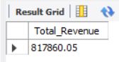
2. Average Order Value
SELECT ROUND(SUM(total_price) / COUNT(DISTINCT order_id)) AS Avg_order_Value FROM pizza_sales
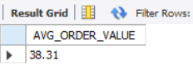
3. Total Pizzas Sold
SELECT SUM(quantity) AS Total_pizza_sold FROM pizza_sales
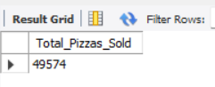
4. Total Orders
SELECT COUNT(DISTINCT order_id) AS Total_Orders FROM pizza_sales
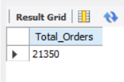
5. Average Pizzas Per Order
SELECT ROUND(SUM(quantity) / COUNT(DISTINCT order_id),2) AS Avg_Pizzas_per_order FROM pizza_sales
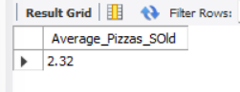

B. Daily Trend for Total Orders
SELECT DAYNAME(order_date) AS order_day, COUNT(DISTINCT order_id) AS total_orders FROM pizza_sales
GROUP BY DATENAME(order_date)
Output:
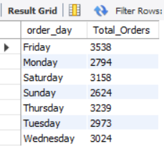
C. Monthly Trend for Orders
select MONTHNAME(order_date) as Month_Name, COUNT(DISTINCT order_id) as Total_Orders
from pizza_sales
GROUP BY MONTHNAME(order_date);
Output
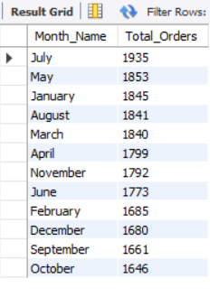

D. % of Sales by Pizza Category
SELECT pizza_category, ROUND(SUM(total_price),2) as total_revenue,
ROUND(SUM(total_price) * 100 / (SELECT SUM(total_price) from pizza_sales),2) AS PCT
FROM pizza_sales
GROUP BY pizza_category
ORDER BY PCT DESC;

Output
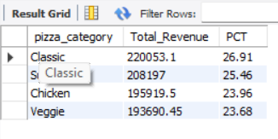
E. % of Sales by Pizza Size
SELECT pizza_size, ROUND(SUM(total_price)) as total_revenue,
ROUND(SUM(total_price) * 100 / (SELECT SUM(total_price) from pizza_sales),2) AS PCT
FROM pizza_sales
GROUP BY pizza_size
ORDER BY PCT DESC;
Output
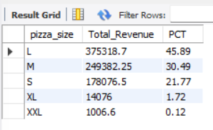
F. Total Pizzas Sold by Pizza Category
SELECT pizza_category, SUM(quantity) as Total_Quantity_Sold
FROM pizza_sales
GROUP BY pizza_category
ORDER BY Total_Quantity_Sold DESC
Output
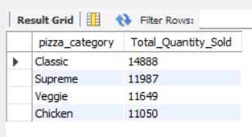

G. Top 5 Pizzas by Revenue
SELECT pizza_name, SUM(total_price) AS Total_Revenue
FROM pizza_sales
GROUP BY pizza_name
ORDER BY Total_Revenue DESC
LIMIT 5;
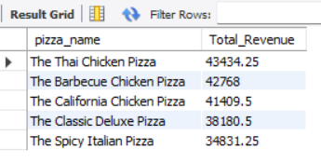
H. Bottom 5 Pizzas by Revenue
SELECT pizza_name, SUM(total_price) AS Total_Revenue
FROM pizza_sales
GROUP BY pizza_name
ORDER BY Total_Revenue ASC
LIMIT 5
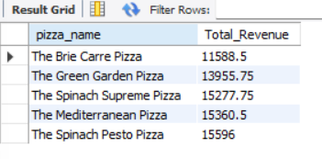
I. Top 5 Pizzas by Quantity
SELECT pizza_name, SUM(quantity) AS Total_Pizza_Sold
FROM pizza_sales
GROUP BY pizza_name
ORDER BY Total_Pizza_Sold DESC
LIMIT 5;
Output
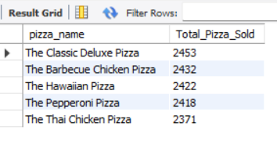
J. Bottom 5 Pizzas by Quantity
SELECT pizza_name, SUM(quantity) AS Total_Pizza_Sold
FROM pizza_sales
GROUP BY pizza_name
ORDER BY Total_Pizza_Sold ASC
LIMIT 5;
Output
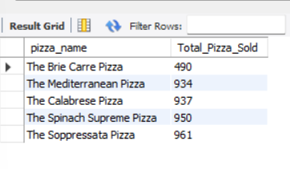
K. Top 5 Pizzas by Total Orders
SELECT pizza_name, COUNT(DISTINCT order_id) AS Total_Orders
FROM pizza_sales
GROUP BY pizza_name
ORDER BY Total_Orders DESC
LIMIT 5;
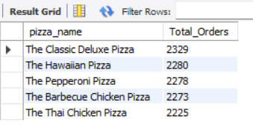
L. Bottom 5 Pizzas by Total Orders
SELECT pizza_name, COUNT(DISTINCT order_id) AS Total_Orders
FROM pizza_sales
GROUP BY pizza_name
ORDER BY Total_Orders ASC
LIMIT 5;
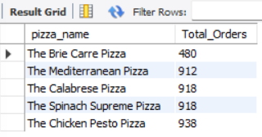
NOTE
If you want to apply the pizza_category or pizza_size filters to the above queries you can use WHERE clause. Follow some of below examples
SELECT Top 5 pizza_name, COUNT(DISTINCT order_id) AS Total_Orders
FROM pizza_sales
WHERE pizza_category = 'Classic'
GROUP BY pizza_name
ORDER BY Total_Orders ASC

